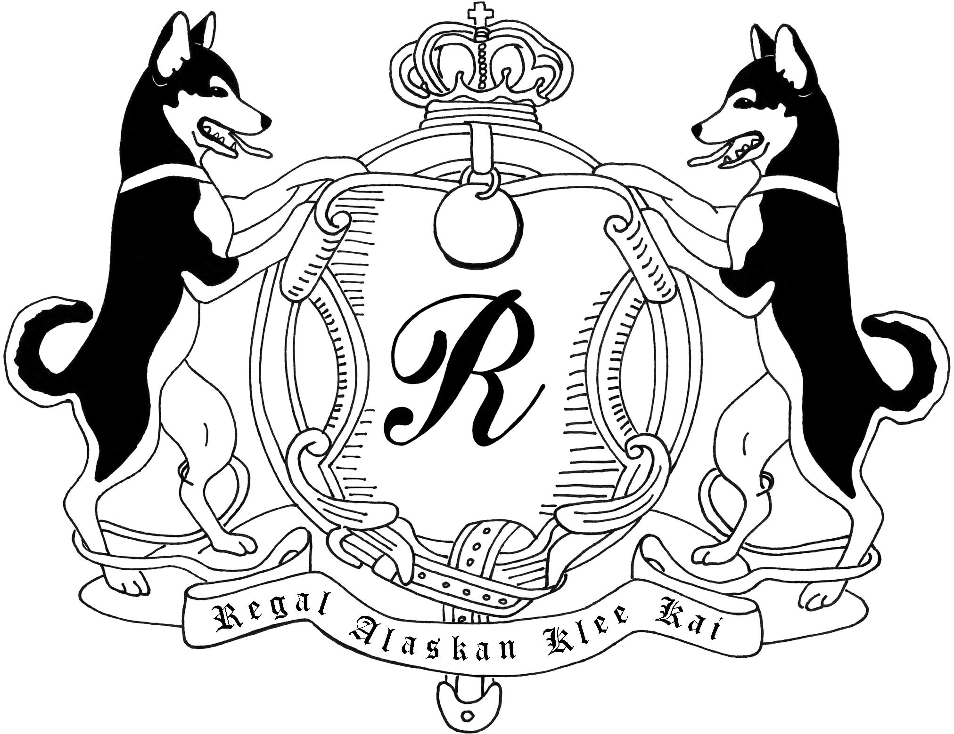
Thank you for your interest in Regal Alaskan Klee Kai

Before you fill this out please realize that these puppies are family to us and we want you to feel the same about them.
Puppies are a lifetime commitment. Once you fill out this questionnaire, this will also be included in your contract that goes with your potential AKK from our pack. All puppies will have a spay/neuter contract, unless you are an established and approved AKK breeder. We DO NOT ship PUPPIES, but can meet you at the airport you fly into so that you may fly back with your puppy. We can ship Adult dogs if needed, within the USA, at an additional cost to you. We are not shipping International at this time. Once we receive your completed questionnaire with references, we will contact you with any questions we may have. If approved, you will need to put a deposit of $500.00 to be on our wait list. We do have a small waiting list and those who are approved and put down a deposit are guaranteed a puppy within the next few litters. The Deposit is nonrefundable, but your deposit will go towards the full payment of the puppy. If you have not heard back from us within a week, please contact us to make sure we received your questionnaire. We look forward to hearing from you. If you have any questions, please don’t hesitate to contact me. Thank you.

Regal Alaskan Klee Kai Questionnaire: Your Information:
Name: Address:
City/State/Zip code: Home Phone:
Cell Phone: Email Address:

- Where did you hear about this breed AKK? And where did you hear about our Kennel?

- Have you ever met an AKK in person? And if so what were your thoughts of this breed?

- What attracted you to this breed? And what Concerns do you have about this breed?

- AKK tend to shed at least 2 times a year, will that be an issue for your family? And is there anyone in your household that is allergic to animals?

- Would you be willing to join the Alaskan Klee Kai Association of America club (AKKAOA) for a year? This way you may learn more about this breed?

- Who will the Primary caretaker be for your potential AKK?

- Do you have any children? If so how many and what are the ages?

- If you have children have they been taught the proper way of handling and playing with a puppy or dog? If yes please explain:

- How many other animals do you own? What are their breeds and ages?

- Which animals live in your house currently?

- Which of your animals are spayed or neutered?

- What happened to your past Dogs?

- Which dog breeds have you owned? Which of those breeds did you like or dislike and why?

- What type of establishment do you live in? (House, Condo, Apt,)

- Do you rent or own?

- Do you have a fenced in yard at the place you live at? If so what type of fencing and how high?

- If you rent are there any Limitations for having a dog on the premises? If so what are they?

- If you do not own your own home please provide the name and phone number of the Landlord or Owner of the dwelling:
Name:
Phone Number:

- Where will your puppy be spending most of its time? Indoors, outdoors, both?

- How many people work in your house? How many people stay home most of the day?

- How many hours a day would your AKK be home alone?

- Where will your AKK be left when you leave the house?

- Do you plan on crate training your AKK?

- Do you plan on taking your AKK to any classes (Puppy, Obedience, etc.)?

- What are your solutions if your AKK pick up any bad habits? Like biting, barking or anxiety?

- Are you interested in getting an AKK for dog sports such as; Obedience, conformation, agility, fly ball, dock jumping, or any other dog related activities?

- Are you interested in Breeding?

- Have your ever been a breeder or currently a breeder? If so which breeds?

- If you get a Pet Quality AKK will you abide by our contract in getting it spayed or neutered within the time frame on your contract?

- Have you ever been Convicted or Accused of Animal Abuse? If yes explain:

- Do you have any obligations or concerns regarding your potential AKK?

- Why do you feel like your household and family would be a good home for an AKK?

- Our Contract states that if for any reason you can no longer provide and keep your AKK that you receive from us, you will have to return the AKK to us so that we may find it a loving proper home. Will you be able to abide by this?

- If you were able to get one of our AKK from our pack, per our sales contract, it states you need to keep in contact with us for the first 2 years. We will need updates, which will include; photos, height, weight, health, and how things are going with your AKK. Would you be willing to do this?

References: (You will need 3 references, and 1 must be the Vet you use)
Name: Phone: Email: Relationship:

Name: Phone: Email: Relationship:

Veterinary Hospital Name: Vets Name:
Phone: Address: Email:

Preferences:
(Please fill these out accordingly by; 1. being your top priority, 2. being second choice, and so on)
What Gender would you prefer? (Male or female) 1.
2.

Which colors do you prefer? (Black, Grey, Red, white) “We do not purposely breed for the color white, but if we should get one, it is an option”
1.
2.
3.
4.
What size AKK do you prefer? (Toy, Miniature, Standard) 1.
2.
3.
What color eyes do you prefer? (Blue eyes, Brown eyes, Bi-eyed, Party eyed) 1.
2.
3.
4.

What age range are you looking for? (Puppy, Adult, Senior) 1.
2.
3.
Are you looking for a Pet Quality, Sports dog (with a spay/neuter contract) or a Breeding/Showing quality?
1.
2.
3.

Once you have answered all the questions and emailed it back to us, we will contact you with any questions we may have. If you have been approved for our waiting list, we will send you a deposit contract. You will have to sign it and send it back with your deposit. At any time between the deposit being made and the puppy being delivered/picked up, I reserve the right to cancel the contract, at any time, for any reason, if I feel like it’s not in the best interest of the puppy/dog. Thank you for taking the time to fill this out and choosing our kennel. We look forward to hearing from you. Please don’t hesitate to contact us with any questions or concerns.

Regal Alaskan Klee Kai
RegalAlaskanKleeKai@gmail.com

Also Check out our Facebook for updates
www.Facebook.com/RegalAKK

Also Check us out on Instagram !

